**Lesson 4 Demo 2**

**Perform Custom Formatting - Dates**



**Steps to be followed:**

**Step 1: Open the Excel file**

* 1. Open the file named **Formatting.xlsx**

**Step 2: Apply custom formatting on the Date column**

* 1. Choose the column **Dates**

* 1. Click on More number formats under Format in the Home tab

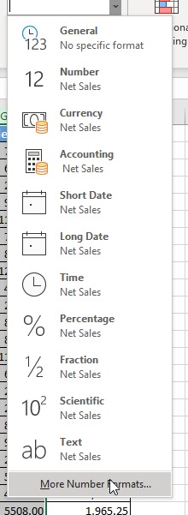

* 1. Choose Custom and type dd-dddd-mmm-yyyy in the **Type** textbox. Click on OK

* 1. Expand the column with the Dates field. The formatted dates appear like below:

